TRANSFER LEARNING TECHNIQUES IN PERFORMANCE ANALYSIS OF BRAIN TUMOR CLASSIFICATION

Shivam Tyagi, Saubhagya Sharma
Department of Computer Science and Engineering Technology
Sharda University
Uttar Pradesh, India

Shubham Priyadershi
Department of Computer Science and Engineering Technology
Sharda University
Uttar Pradesh, India

Ms.Khushi
Department of Computer Science and Engineering Technology
Sharda University
Uttar Pradesh, India

Prof. Tejaswi Khanna
Department of Computer Science and Engineering Technology
Sharda University
Uttar Pradesh, India

Abstract— The brain tumors are the extraordinarily familiar and threatening illness border to a bit age expectancy of their excessive grade hence remedy designing might be a key level to decorate the usual of life of sufferers typically various photo strategies like automatic axial tomography ct resonance imaging MRI and ultrasound photo accustomed degree the tumor in the course of a mind lung liver breast prostate and so on mainly in the course of this paintings MRI images are accustomed diagnose tumor inside the mind however the big amount of understanding generated with the aid of using MRI experiment thwarts guide type of tumor vs non-tumor in the course of a specific time but it having a few hassle i.e., accurate quantitative measurements is furnished for confined variety of images consequently trusty and automated type topic vital to forestall the loss of life price of human the automatic mind tumor type is extraordinarily hard project in large special and structural variability of near vicinity of mind tumor in the course of this paintings computerized mind tumor detection is deliberate with the aid of using victimization Convolutional neural networks CNN type the deeper layout fashion is achieved with the aid of using victimization tiny kernels.
.
Keywords: Brain Tumor, Magnetic Resonance Imaging(MRI), Image processing,VGG16, classification, Convolutional Neural Networks, Keras.

Introduction
Image augmentation is a method of changing the present statistics to create a few greater statistics for the version schooling system. In different words, it's far the system of artificially increasing the to be had dataset for schooling a deep learning model.
Image classification is the way of categorizing and labeling set of pixels or vectors inside an photo primarily based totally on precise rules. The categorization regulation may be devised the use of one or extra spectral or textural characteristics. Two standard techniques of category are 'supervised' and 'unsupervised’.
The learning (training) part and the classification (testing) section of supervised classification are two separate machine learning challenges. The training data was made up of a predetermined number of training samples. Each pattern is a couple inclusive of the function vectors and a label. In the training section, the supervised classification set of rules analyzes the categorised training statistics and produces classification rules. In the testing section, the formerly unseen new test statistics are categorized into classes (labels) primarily based totally at the generated classification rules. The categorized labels are then in comparison with the labeled test statistics to validate the overall performance of the supervised classification.
It is a famous technique in deep mastering wherein pre-educated models are used because the place to begin on laptop imaginative and prescient and natural language processing tasks given the good sized compute and time sources required to expand neural network models on those troubles and from the massive jumps in ability that they offer on associated troubles.
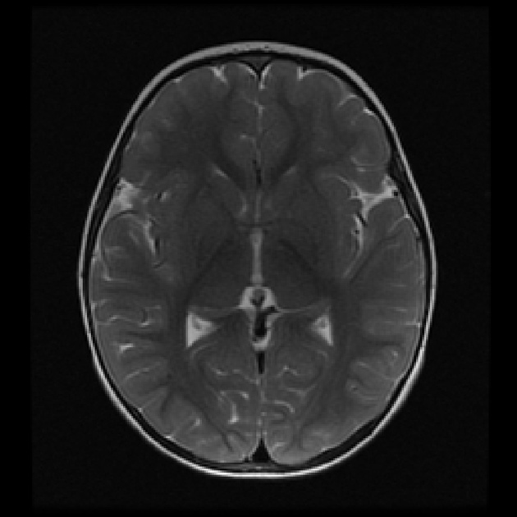
Fig 1.Non Tumor Image
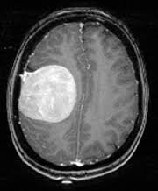
Fig 2 Tumor Image

Related Works
VGG16 is a simple and widely used Convolutional Neural Network (CNN) model used by ImageNet, a virtual web site used in powerful visual software program research. VGG16 Architecture emerged and augmented by the methods of Karen Simonyan and Andrew Zisserman from Oxford University, during the 12 months of 2014, on their theme “Extremely Extensive Networks to Transform High Image Recognition.” ‘VGG’ is the abbreviation for Visual Geometry Group ,that's a collection of researchers on The University of Oxford who evolved this structure ,and ‘sixteen’
means that this structure has sixteen layers.

The Inception-ResNet-v2 network is a convolutional neural community that has been skilled on over 1,000,000 photographs from the ImageNet database. The community is 164deeper layers and may split a thousand shortcuts categories of objects, including keyboard, mouse, pencil, and lots of animals. As a result, the community has found it bring out the rich presentations of the great variety feature with snap shots. The public has a photo size 299-by-299, and the output is a list of displayed items possible beauty.

MobileNetV2 is a CNN structure designed to carry out properly on mobile devices. It is constructed absolutely on an inverted residual structure, with residual connections placed the various bottleneck layers. As a source of non-linearity, the intermediate growth layer uses light-weight depth wise convolutions to clear out functions. MobileNetV2's overall structure contains a preliminary completely convolutional layer with 32 filters, that's determined via 19 residual bottleneck layers.
.

Proposed Method
Within this paper, we used multiple transfer learning techniques to come up with the optimal result within the least time. Every step of this process is carried out via different techniques – those techniques are referenced below:
- Gray scaling the test image: To get better differentiation of lesion across the whole image we use this technique, otherwise, if we skip this lay then we need to use CNN or Deep Learning.
- Preprocessing: The main task of Preprocessing is to improve appearance of test pictures and prepare them extended administration by a human or machine visual system. Furthermore, advanced processing assists in image spectrums improvement such as signal to noise ratio, removing unnecessary noise, appearance, and unwanted overlapping background parts, and maintaining its edges.

C. Using Image augmentation: An augmented picture generator can be handily made involving Image Data Generator API in Keras. Image Data Generator produces groups of picture information with ongoing information increase. The most fundamental codes to make and arrange Image Data Generator and train profound brain network with increased pictures. Image augmentation is a method of changing the present statistics to create a few greater statistics for the version schooling system. In different words, it's far the system of artificially increasing the to be had dataset for schooling a deep learning model.
D. Image classification: It is the way of categorizing and labeling set of pixels or vectors inside an photo primarily based totally on precise rules. The categorization regulation may be devised the use of one or extra spectral or textural characteristics. Two standard techniques of category are 'supervised' and 'unsupervised'.

IV. Performance Evaluation Metrics

- Accuracy: The accuracy metric is usually calculated as a ratio of right forecasting to total no of items tested.
Formula for Accuracy= (TP + TN) / TP + TN + FP + FN
2. Precision: Precision is used to calculate total number of positive layout of the positive phase that are correctly from total no of forecasted layout.
Formula for Precision = TP / (TP+FP)
3. Recall: It is the % of positive patterns that are accurately classified and calculated as recall.
Formula for Recall= TP / (TP+TN)

4. Loss: The mean error across samples for each update (batch) or the average of all updates for the samples is called loss.
5. AUC: It is an analysis of ROC curve which calculates the classifier capabilities to discriminate in different classes.AUC measures how good a model is able to differentiate from positive & negative classes. When the AUC is more, the better the model is.
6. True Positive (TP: .It gives the result where the model correctly forecasts for the class which is positive.
7. True Negative (TN): It gives the result where the model correctly forecasts for the class which is negative.

8. False Positive (FP): It gives the result where the model wrongly forecasts for the class which is positive.

9. False Negative (FN): It gives the result where the model wrongly forecasts for the class which is negative.

V. RESULTS
1. Simple CNN Model-
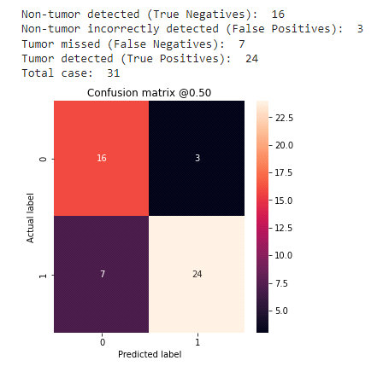
Fig 3: Confusion Matrix Simple CNN
- INCEPTIONRESNETV2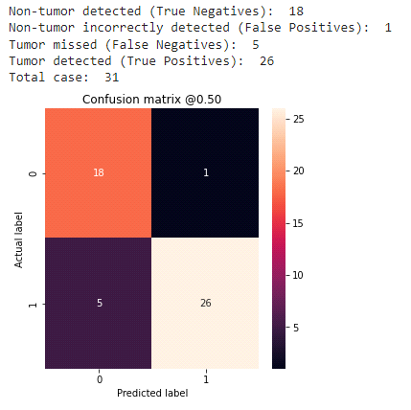
Fig 4: Confusion Matrix Inception ResnetV2
3. VGG16
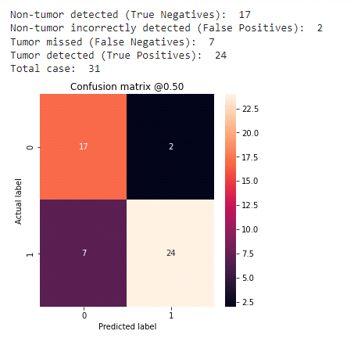
Fig 5: Confusion Matrix VGG16

4. MobileNetV2
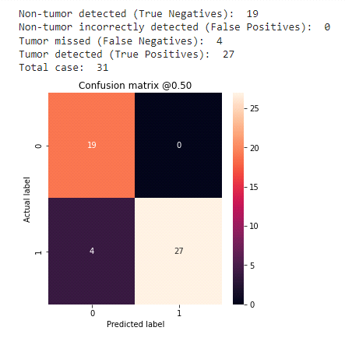
Fig 6: Confusion Matrix MobileNetV2

VI. CONCLUSION.
This study compares several CNN constructed entirely on models of transfer learning, that correctly categorize brain MRI pictures as tumors. We used Transfer Learning based different CNN models, such as VGG16, InceptionResNetV2,& MobileNetV2, to complete the picture classification technique, as well as a Simple CNN architecture that works like classifier in forecasting evaluation in tumor detection. This is the most general health problem linked with the human brain is a brain tumor. The accuracy of validation drops when the accuracy of training grows, then architecture is expected to have overfitting issues. We concluded after evaluating examination of several pre-trained CNN architecture, like VGG-16, InceptionResNetV2, and MobileNetV2, that MobileNetV2 provides greater accuracy on the trained dataset .Below you'll be able to discover desk of metrics for 100 epoch run.

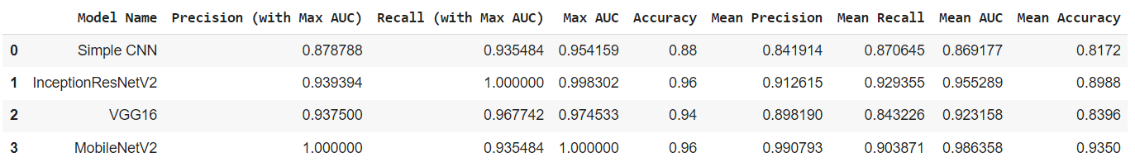
Fig 7: Performance Evaluation Metrics

References

[1] G. B. Janardhana Swamy, Anusha, Lavanya, Meghashree, and Sangeetha, “Brain tumor detection using convolutional neural network,” International Journal for Research in Applied Science and Engineering Technology, vol. 8, no. VI, 2020.

[2] D. Dheeraj and H. S. Prasantha, “Study of machine learning vs. deep learning algorithms for detection of tumor in human brain,” International Journal of Computer Science and Engineering, vol. 8, no. 1, pp. 2347–2693, 2020.

[3] H. Barad and A. Patel, “Application of machine learning and deep learning methods for brain tumor identification and classification,” International Journal of Recent Technology and Engineering, vol. 86 pages, 2020.

[4] M. Talo, U. B. Baloglu, O Yildirim, and U. R. Acharya, “Application of Deep Transfer Learning for Automated Brain Abnormality Classification Using MR Images,” Cognitive Systems Research, vol. 54, 2019.

[5] A. Gudigar, U. Raghavendra, T. R. San, E. J. Ciaccio, and U. R. Acharya, “Application of Multiresolution analysis for automated detection of brain abnormality using MR images: a comparative study,” Future Generation Computer Systems, vol. 90, pp. 359–367, 2019.

[6] M. Visser, D. M. J. M¨uller, R. J. M. V. Duijn et al., “Inter-rater agreement in glioma segmentations on longitudinal MRI,” NeuroImage: Clinical, vol. 22, Article ID 101727, 2019.

[7] H. A. Khan, W. Jue, M. Mushtaq, and M. U. Mushtaq, “Brain tumor classification in MRI image using convolutional neural network,” Mathematical Biosciences and Engineering, vol. 17, no. 5, pp. 6203–6216, 2020.

[8] B. Anilkumar and P. R. Kumar, “Classification of MR brain tumors with deep plain and residual feed forward CNNs through transfer learning,” International Journal of Engineering and Advanced Technology (IJEAT) ISSN, vol. 8, no. 6, 2019.

[9] N. Abiwinanda, M. Hanif, S. Hesaputra, A. Handayani, and T. R. Mengko, “Brain Tumor Classification Using Convolutional Neural Network,” in Proceedings of the World Congress on Medical Physics and Biomedical Engineering, Springer, Prague, Czech Republic, June 2019. [10] M. D. A. B. Siddique, S. Sakib, M. M. R. Khan, A. K. Tanzeem, M. Chowdhury, and N. Yasmin, “Deep convolutional neural networks model-based brain tumor detection in brain MRI images,” in Proceedings of the 4th International conference on I-SMAC (IoT in Social, Mobile, Analytics and Cloud) (I-SMAC 2020), Palladam, India, October 2020.

[11] G. Hemanth, M. Janardhan, and L. Sujihelen, “Design and implementing brain tumor detection using machine learning approach,” in Proceedings of the 2019 3rd International Conference on Trends in Electronics and Informatics (ICOEI), pp. 1289–1294, Tirunelveli, India, April 2019.

[12] S. Deepak and P. M. Ameer, “Brain tumor classification using deep CNN features via transfer learning,” Computers in Biology and Medicine, vol. 111, Article ID 103345, 2019.

[13] C. Cheroni, N. Caporale, G. Testa, Autism spectrum disorder at the crossroad between genes and environment: contributions, convergences, and interactions in ASD developmental pathophysiology, Mol. Autism. 11 (2020).

[14] A. Tiwari, S. Srivastava, and M. Pant, “Brain tumor segmentation and classification from magnetic resonance images: review of selected methods from 2014 to 2019,” Pattern Recognition Letters, vol. 131, pp. 244–260, 2020. [15] A. Rehman, S. Naz, M. I. Razzak, F. Akram, and M. Imran, “A Deep Learning-based framework for automatic brain tumors classification using transfer learning,” Circuits, Systems, and Signal Processing, vol. 39, no. 2, pp. 757–775, 2020.

